**1.** **INTRODUCTION**

**1.1 OVERVIEW**

An Android App for Financial planning is the starting point for effective personal finance management. It involves three important elements: a realistic budget, well-defined financial goals and real-time tracking.

A budget helps you stay committed to your financial goal, while real-time tracking helps you take the right actions at the right time. However, money management is easier said than done. Budgeting and real-time tracking can be challenging, requiring considerable time and effort investment. But money management apps can help. These apps are extremely useful in helping you effectively manage your money and personal finances.

**1.2 PURPOSE**

The purpose of implementing a money management program is to put you incomplete control of your financial decisions, future savings goals and create a lifestyle by design. Savings plan – setting a plan to suit your desired lifestyle but balance and align this with your longer term financial goals.

Personal finance involves evaluating your income, your financial needs, and your expenses and allocating your money accordingly. Keeping track of your income and how you save and spend your money is called budgeting. Managing your money can help you live a self-determined and secure life.

**2. PROBLEM DEFINITION AND DESIGN THINKING**

The app allows user to keep track of their expenses and accounts, and provides an over view of their financial status.

Users can set a budget for various expenses and view their progress towards it.

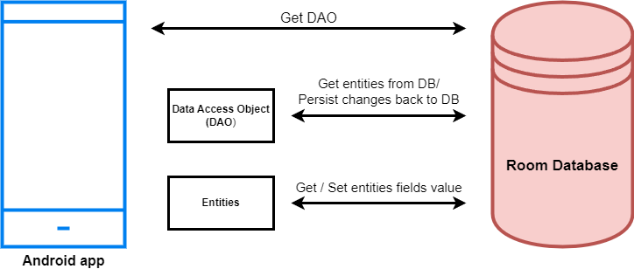

**3.** **RESULT**

**3.1 LOGIN PAGE:**

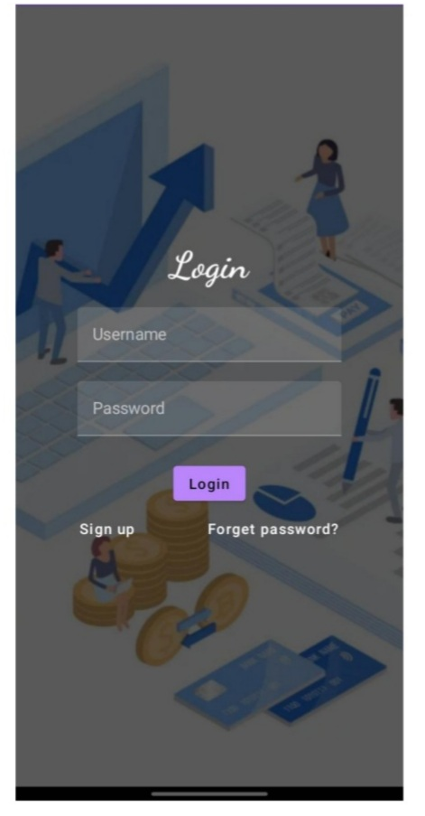

**3.2** **Register Page:**

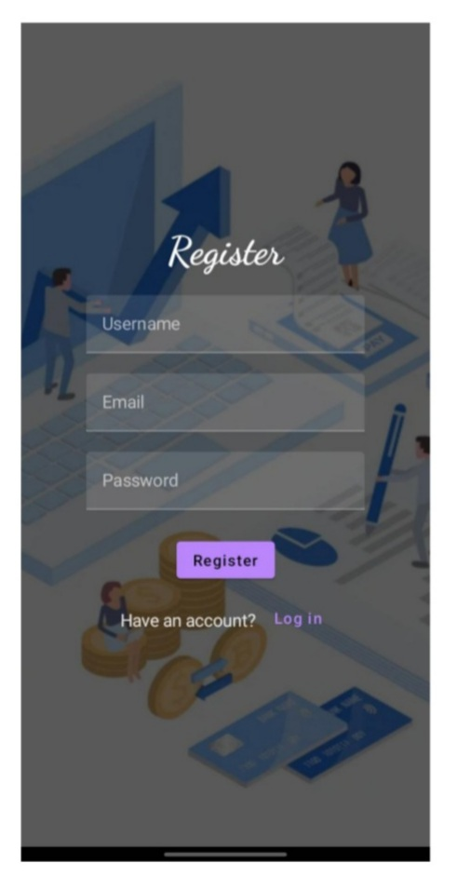

**3.3 MAIN PAGE:**

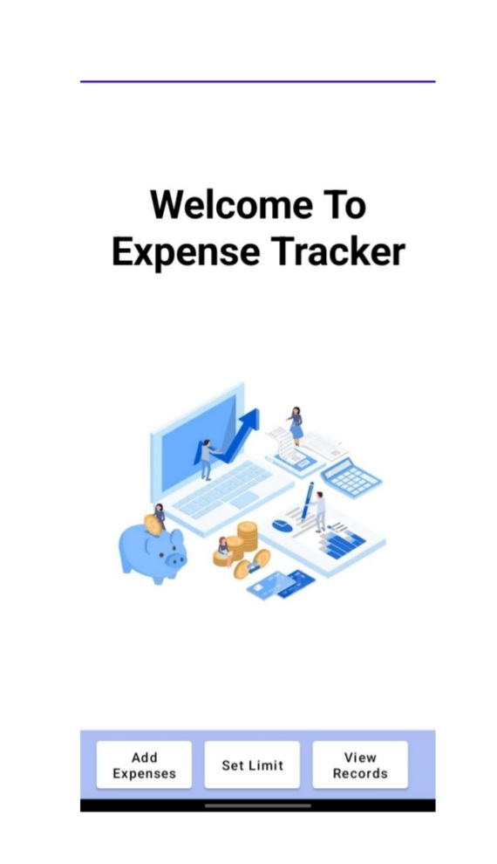

**4. ADVANTAGES &DISADVANTAGES**

The aim of proposed system is to develop a system of improved facilities.

They are:

|  |  |
| --- | --- |
| **Advantages** | **Disadvantages** |
| * Economical | * Obsession |
| * Convenient | * Disagreements |
| * Homogeneous | * It’s easy to waste |
| * Stability | * Bad decisions. |
| * Elasticity | * Conflict in Relationships |

**5.** **APPLICATIONS:**

1. Supersplit: It is the easiest way to split the expenses among friends, colleagues, and flatmates without causing a strain in your relationship.

2. Moneyview: It is a money managemet app provides you with real-time vidibility into your finances.

3. Goodbudget: It is your go- to app for daily expenses.

4. Money Manager: It is one of the best money management apps that makes handling expenses enjoyable.

5. Wallet: It allows you to bank under one roof. It connects all your bank accounts and links to your debit and credit and other payment systems that you use.

**6. CONCLUSION**

Personal financial management is done by every individual on some level. The key is to strike the right balance between income, expenses, savings and investments. This balance will ensure that the personal financial planning and mamgement of the individual are optimum. To develop this project will have faced many problem but we hardly tried to develop this project.

**7. FUTURE SCOPE**

The future scope of our project is valuable. Our project time duration was only one years. In this time we developed our project. It was very difficult to complete project within this time duration. As for other future developments, the following can be done:

* We will manage the accounts management system.
* We update our database.
* We can create the financial apps.

**8.** **Appendix:**

**Build gradle:**

|  |
| --- |
| buildscript { |
|  | ext { |
|  | compose_ui_version = '1.2.0' |
|  | } |
|  | }// Top-level build file where you can add configuration options common to all sub-projects/modules. |
|  | plugins { |
|  | id 'com.android.application' version '7.4.1' apply false |
|  | id 'com.android.library' version '7.4.1' apply false |
|  | id 'org.jetbrains.kotlin.android' version '1.7.0' apply false |
|  | } |

**Compiler.xml:**

|  |
| --- |
| <?xml version="1.0" encoding="UTF-8"?> |
|  | <project version="4"> |
|  | <component name="CompilerConfiguration"> |
|  | <bytecodeTargetLevel target="11" /> |
|  | </component> |
|  | </project> |

**Gradle.xml:**

|  |
| --- |
| <?xml version="1.0" encoding="UTF-8"?> |
|  | <project version="4"> |
|  | <component name="GradleSettings"> |
|  | <option name="linkedExternalProjectsSettings"> |
|  | <GradleProjectSettings> |
|  | <option name="testRunner" value="GRADLE" /> |
|  | <option name="distributionType" value="DEFAULT_WRAPPED" /> |
|  | <option name="externalProjectPath" value="$PROJECT_DIR$" /> |
|  | <option name="modules"> |
|  | <set> |
|  | <option value="$PROJECT_DIR$" /> |
|  | <option value="$PROJECT_DIR$/app" /> |
|  | </set> |
|  | </option> |
|  | </GradleProjectSettings> |
|  | </option> |
|  | </component> |
|  | </project> |

**Misc.xml:**

|  |
| --- |
| <?xml version="1.0" encoding="UTF-8"?> |
|  | <project version="4"> |
|  | <component name="ExternalStorageConfigurationManager" enabled="true" /> |
|  | <component name="ProjectRootManager" version="2" languageLevel="JDK_11" default="true" project-jdk-name="Android Studio default JDK" project-jdk-type="JavaSDK"> |
|  | <output url="file://$PROJECT_DIR$/build/classes" /> |
|  | </component> |
|  | <component name="ProjectType"> |
|  | <option name="id" value="Android" /> |
|  | </component> |
|  | </project> |

**Vcs.xml:**

|  |
| --- |
| <?xml version="1.0" encoding="UTF-8"?> |
|  | <project version="4"> |
|  | <component name="VcsDirectoryMappings"> |
|  | <mapping directory="$PROJECT_DIR$" vcs="Git" /> |
|  | </component> |
|  | </project> |